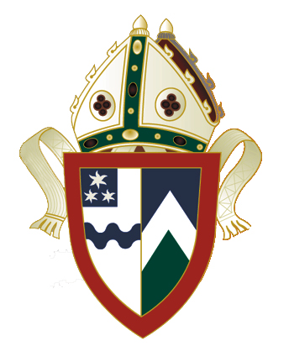
Anglican Diocese of
Waikato & Taranaki
Charlotte Brown House
104 Morrinsville Road
PO Box 21
Hamilton NZ. 3240
Phone: (07) 857-0020
Email:ea@wtanglican.nz
Website: www.wtanglican.nz

James & Edna Clark Scholarship

Terms and Conditions

- The purpose of the scholarship is to provide assistance towards the cost of tertiary study to the children of any person who has been, or is, a clergyperson of the Anglican Church in Aotearoa, New Zealand.

- The scholarship will be awarded to those who have shown pronounced talent in some aspects in the study of science or biology at secondary school and wish to continue their studies in the fields of science or medicine at a university.

- A recipient will have attained the age of 16 but not be over the age of 26 years, at the date the scholarship is awarded.

- A recipient will have been born in New Zealand and have resided continuously in New Zealand for 3 years prior to the application (Holidays excepted).

- The Scholarship covers study in the United Kingdom, Continent of Europe, United States of America, Australia and New Zealand.

- The award shall not exceed three years and the value shall be decided by the Waikato Diocesan Trust Board and may be of differing values from year to year and different amounts between each recipient. This Scholarship may be held with any other scholarship, bursary or fellowship.

- A recipient must have a satisfactory moral character and satisfactory education attainment.

- Application forms must be returned by 31 May and awards will be considered for the current year. There are two forms required, all are available from our website http://www.wtanglican.nz/ or this office.

Contact: The Diocesan Manager
Diocese of Waikato & Taranaki
P.O. Box 21
HAMILTON 3240

E-mail: ea@wtanglican.nz

